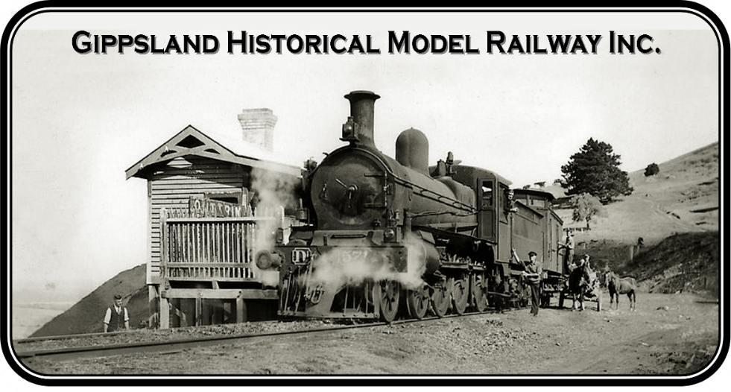
ABN 42 351 371 668 Incorporation No. A0090793P
C/O PO Box Bass 3991
iancole1950@dodo.com.au 0427 553 755
Bendigo Bank BSB: 633 000 Account No. 154535942

MEMBERSHIP/RENEWAL APPLICATION 20?? to 20??

Highlight the GREY boxes, fill-in the details, save, then email the form to iancole1950@dodo.com.au
or mail the form to Gippsland Historical Model Railway Inc, PO Box Bass, 3991

I, FULL NAME wish to apply/reapply to be a member of Gippsland Historical Model Railway and to support the purposes and aims of the association as set out in the Association Rules adopted March 2015.

Purposes and Aims of the Association
Purpose
- To provide a community facility, that being a Hitachi Train Carriage, where members can run model trains.
- To provide a facility with historical significance using a scale model railway that reflects the Wonthaggi Railway Line at the turn of the 20th Century.

Aim
- For the community to have a unique opportunity to learn about and to relive their ancestral past.
- To provide an interactive facility for members to learn new skills.

I understand that if my application for membership is approved, I will abide by the Association’s rules, as listed in the constitution. If you would like a copy of the constitution, please ask a committee person.

Address: STREET AND NUMBER Town: TOWN OR CITY Postcode: 0000

Phone: PHONE (LANDLINE OR MOBILE) Email: EMAIL ADDRESS

Signed: FULL NAME Date: 00/00/2000

Membership fee for Gippsland Historical Model Railway Inc. is valid until 30 June each year. $10.00
If your membership application is rejected your money will be returned.

Donation: $00.00

Total Amount: $00.00
(NOTE: If paying by mail, please enclose a cheque or money order - no cash.)

Under Section 18 of our Rules, any member may, at a reasonable time and free of charge, inspect the register of members. Under Section 59 of the Act, access to the personal information of a person recorded in the register of members may be restricted in certain circumstances. Section 58 of the Act provides that it is an offence to make improper use of information about a person obtained from the Register of Members.

If you would like your personal information to be restricted to only the Committee of Gippsland Historical Model Railway Inc, please write YES. YES

